|  |  |  |
| --- | --- | --- |
| Product Catalogue | D-Sub/DVI/HDMI connecting base |  |
| Connector type | HDMI |  |
| Male and female | Female |  |
| Total number of PINs | 19 |  |
| Row number | - |  |
| Installation method | Supporting pad for bed |  |
| Rated current | 200mA |  |
| Operating temperature range | -10℃~+60℃ |  |

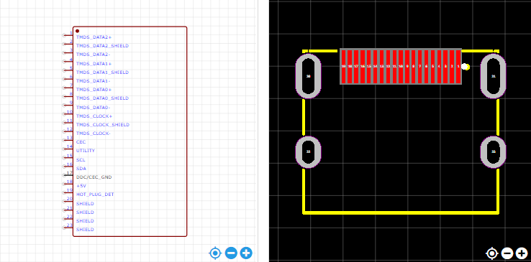

<https://item.szlcsc.com/747097.html>